- Which statement is use to list the information about a table? How do you use this statement? describe employee_data;

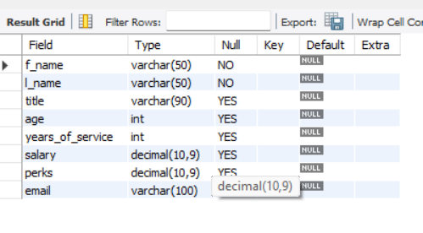
- How would you list all the databases available on the system?
Answer: show databases;
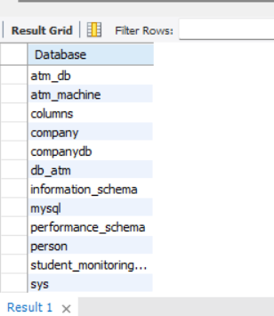

- Write the statement for inserting the following data in employee data table
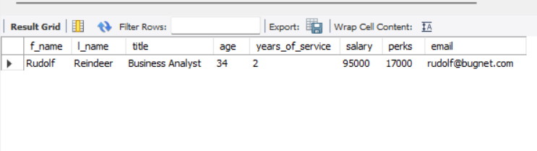
- Give to forms of the SELECT statement that will list all the data in employee_data table
select * from employee_data;
select f_name, l_name, title, age, years_of_service, salary, perks, email from employee_data;
- What will select f_name, email, from employee_data; display?
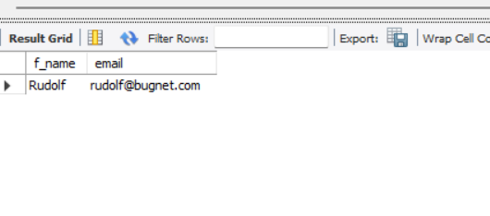
- Write the statement for listing data from salary, perks and yos columns of employee_data table.
select salary, perks, years_of_service from employee_data;

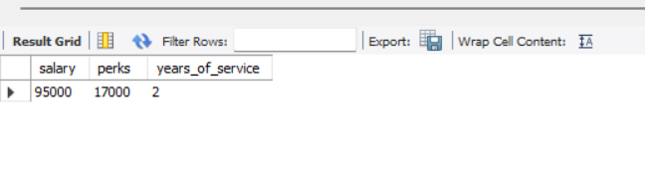
- How can you find the number of rows in a table using the SELECT statement?
select count(*)from employee_data;
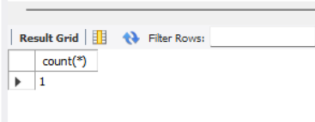
- What will select salary, l_name from employee_data; display?
